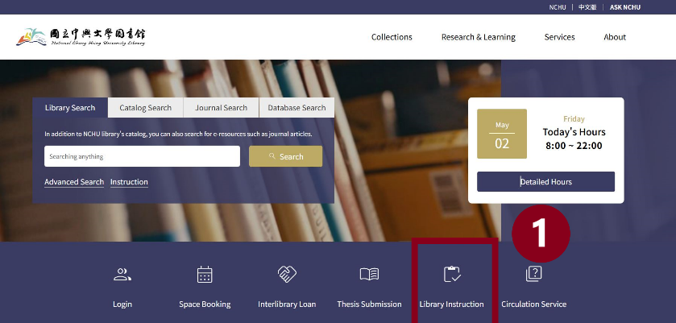
How to register online？
- Directly click the event link to enter
the registration system,
or through NCHU Library homepage
Links (below the fold)
Library Instruction Services

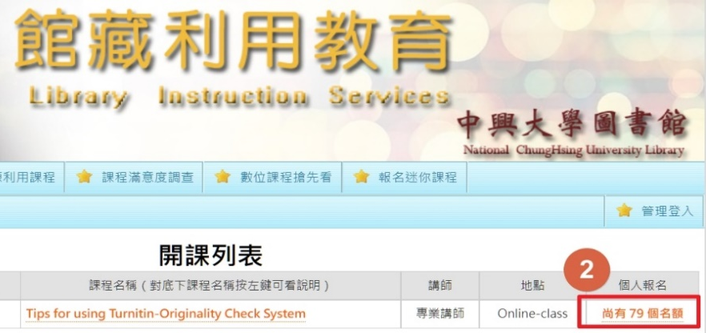
- Click the”Registration quota”to
enter the registration form.

- Fill out the registration form, then click “Register”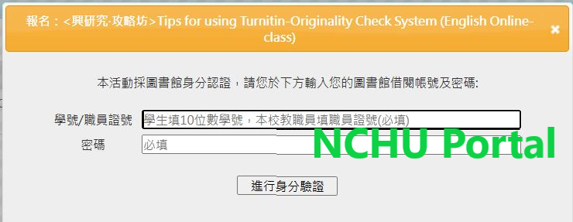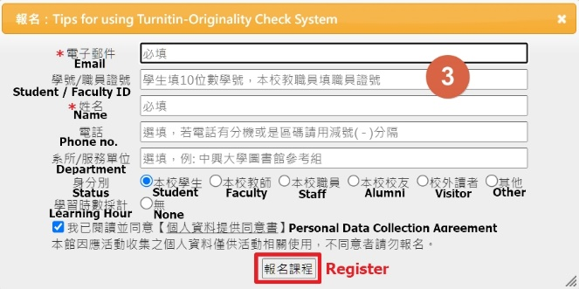
Authentication
Password
Student / Faculty ID
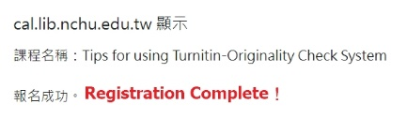
- Registration Complete！

